Cyber lab 6
Areesha Raheel
55039
Question:

Select 5 Kali Linux tools you have not used before (and which were not covered in class).

1. WPScan
Objective: To identify WordPress-related vulnerabilities (where applicable).
Method: CMS vulnerability scanning.
Result: No critical exploitable vulnerabilities were confirmed.
Security Impact: CMS components must be regularly updated.
Risk Level: Low
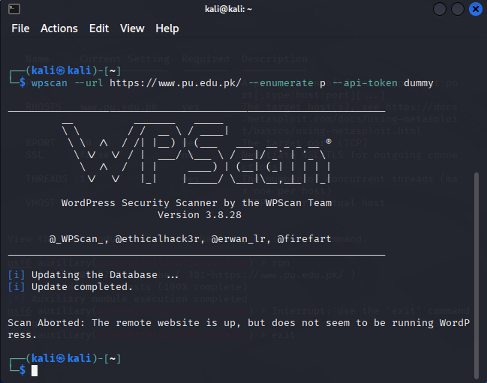

DNSenum
Objective: To enumerate DNS records and subdomains.
Method: DNS enumeration techniques.
Result: DNS records and additional subdomains were identified.
Security Impact: Exposed DNS information may help attackers map the infrastructure.
Risk Level: Low
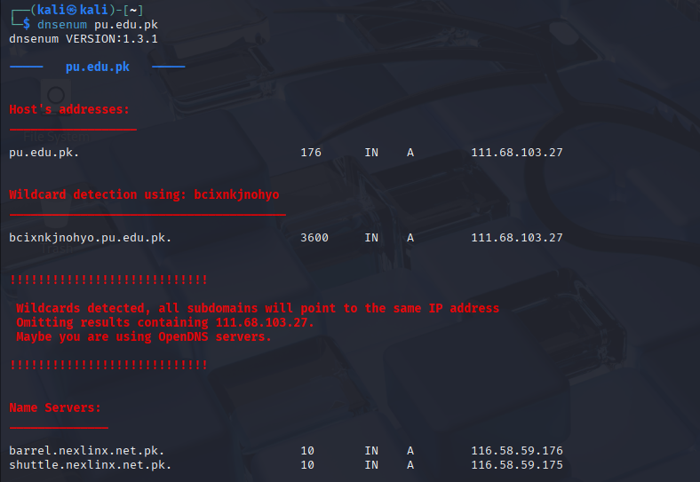
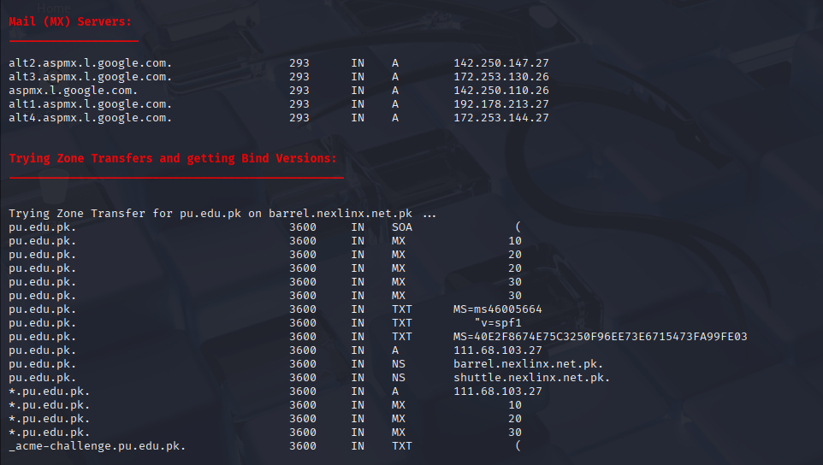

1. Nmap
Objective: To identify open ports and running services.
Method: TCP SYN scan and service detection.
Result: Several open ports and active services were detected.
Security Impact: Open services may be targeted if misconfigured.
Risk Level:Medium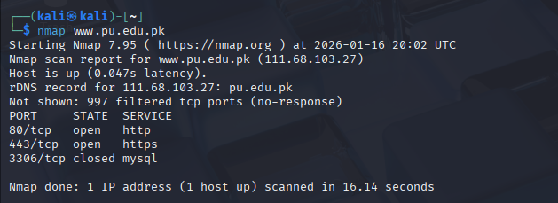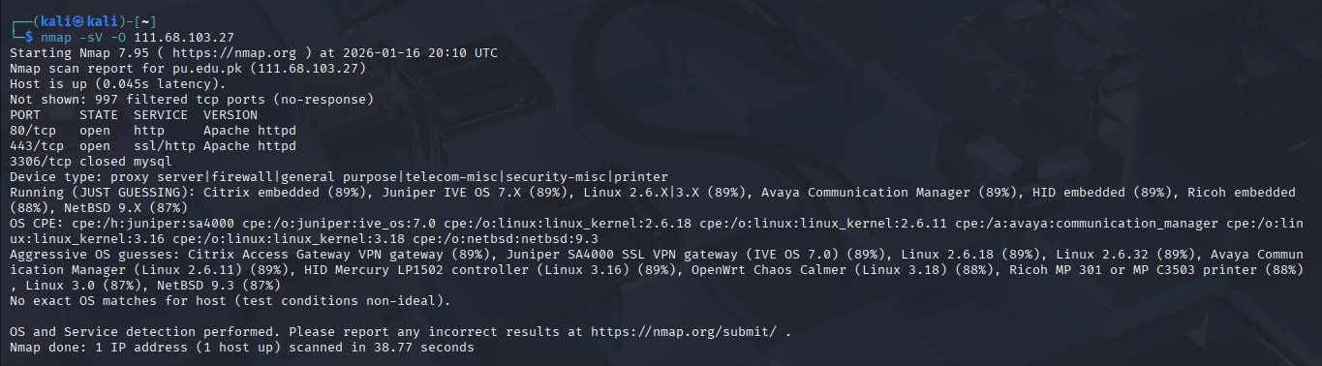
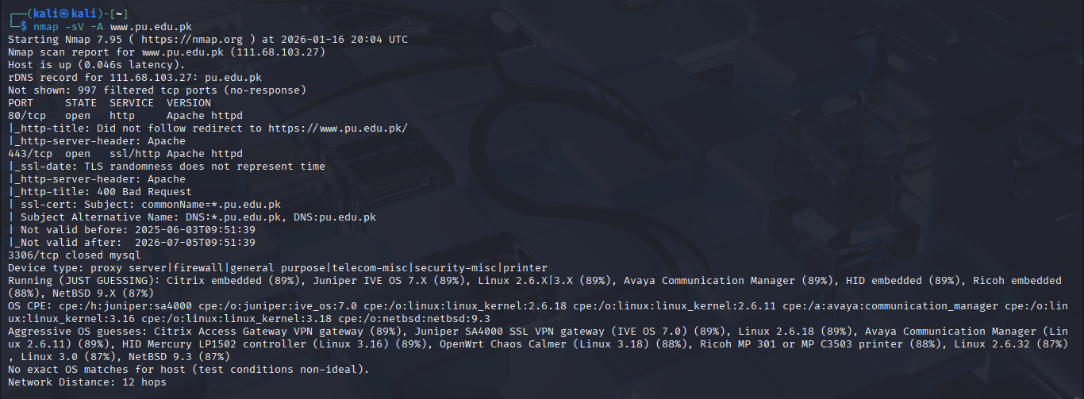

SSLScan
Objective:To analyze the SSL/TLS configuration of the target web server.
Method Used:SSLScan was used to enumerate supported SSL/TLS protocols and cipher suites.
Result:The scan revealed enabled SSL/TLS versions and supported cryptographic ciphers.
Security Impact:Weak or outdated encryption protocols can expose sensitive data to interception.
Risk Level:Medium

